[Subject Line: On demand financial wellness workshop for the COMPANY NAME team] Include if for email, delete if poster

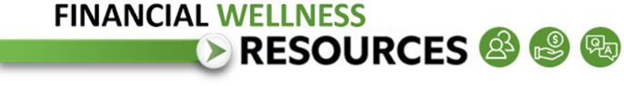
A new workshop for you, on your schedule!
Fidelity, OneDigital Advisors, and Richey May have teamed up to create a complimentary, on demand workshop to help you expand your financial skills.

“Get Started and Save for the Future You”
Learn how to get the most out of your new Fidelity account.
Resource List:
Help Setting Up Your NetBenefits Account.
Learn the benefits of your workplace savings plan, how to enroll, and small steps you can take to save more.

Click here to watch

Brought to you by
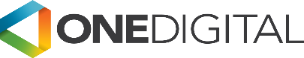
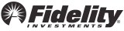

Questions?
Contact
Arturo Arzola
Director, Employee Engagement
OneDigital Financial Services l OneDigital Investment Advisors LLC
713-232-2224 | 800-324-6705 (401k hotline)

Expand your knowledge!

Visit NetBenefits® for more workshops covering a wealth of financial topics, including investing, balancing financial goals, and preparing for retirement.

Investing involves risk, including risk of loss.

[Fidelity and OneDigital Advisors are not affiliated.]

© 2021 FMR LLC. All rights reserved.
Fidelity Brokerage Services LLC, Member NYSE, SIPC, 900 Salem Street, Smithfield, RI 02917
989647.2.0

